**Virat Kholi run Prediction in #CWC 2023 #machine Learning #Regression #justforfun** [**#MakeLearningADailyHabit**](https://web.yammer.com/main/search/threads?search=%23MakeLearningADailyHabit) **#jobseeker #viratKholiFans**

**Dataset**

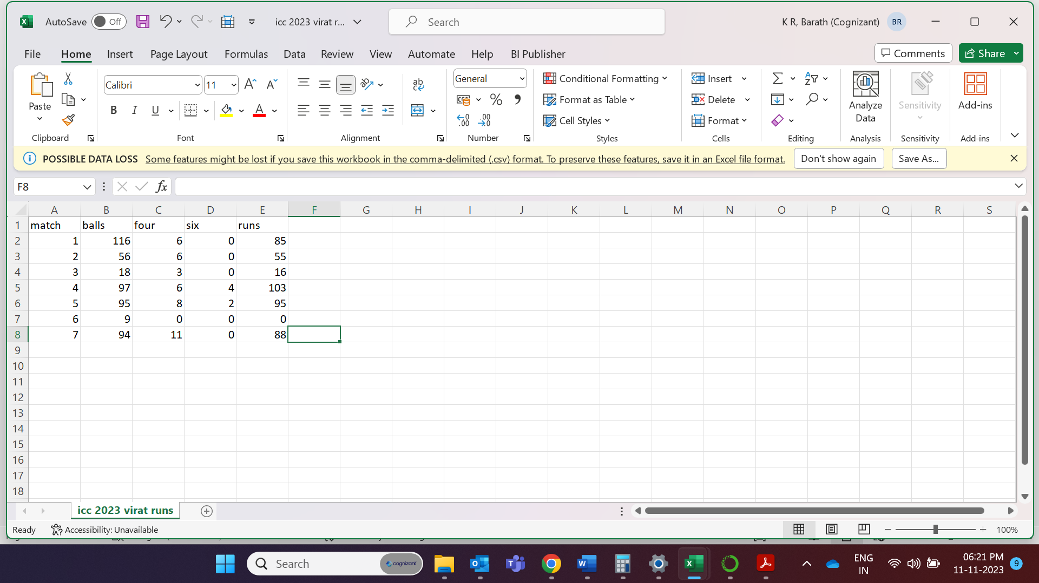

Dataset contains First seven match total balls, four, six, and runs

Dataset has **no null values** so **no pre processing** required

**Independent variable - balls,four,six**

**Dependent variable – runs**

Grid search CV technique is used to find the best optimal hyper tunning parameters

**Decision tree r_score value- 0.98**, Random forest r_score value – 0.94,Support vector mechanics r_score value –0.12, **Multiple regression r_score value -0.98**

**Best model – multiple linear regression,decision tree**

Best Hyper tunning parameter - the R_score value for the best **parameter {'criterion': 'squared_error', 'max_features': 'sqrt', 'splitter': 'best'}**

**Check the comment section for 8th and 9th match predicted run and actual runs**

**9th match**

predicted run

actual run

